**HUMAN BIOLOGY – YEAR 12**

**TASK 2 – ENDOCRINE SYSTEM DISORDERS VALIDATION TEST**

**Part A – Research**

Each dot-point marked overall for all hormones.

Use this table to mark each point to be covered

|  |  |
| --- | --- |
| Description | Mark |
| Comprehensive:*:*   * All hormones written about in full detail in relation to dot point being covered * Use scientific language correctly | 4 |
| All of the above   * Some minor error * Not always scientific language | 3 |
| Sound   * Not every hormone covered in great detail * Uses everyday terminology * Errors | 2 |
| Attempt   * Attempts made but sections missing/incomplete * Use everyday language * Errors | 1 |
| TOTAL | **/4** |
| OVERALL TOTAL | **/20** |

* **If no reference list with at least FOUR references: -3 marks**
* **Handed on correct day: 2 marks**

**Part B – In-class validation questions (35 marks)**

1. With the aid of a negative feedback loop diagram explain how the body usually maintains hormones. You may refer to one of the hormones you researched to help your explanation.

(6 marks)

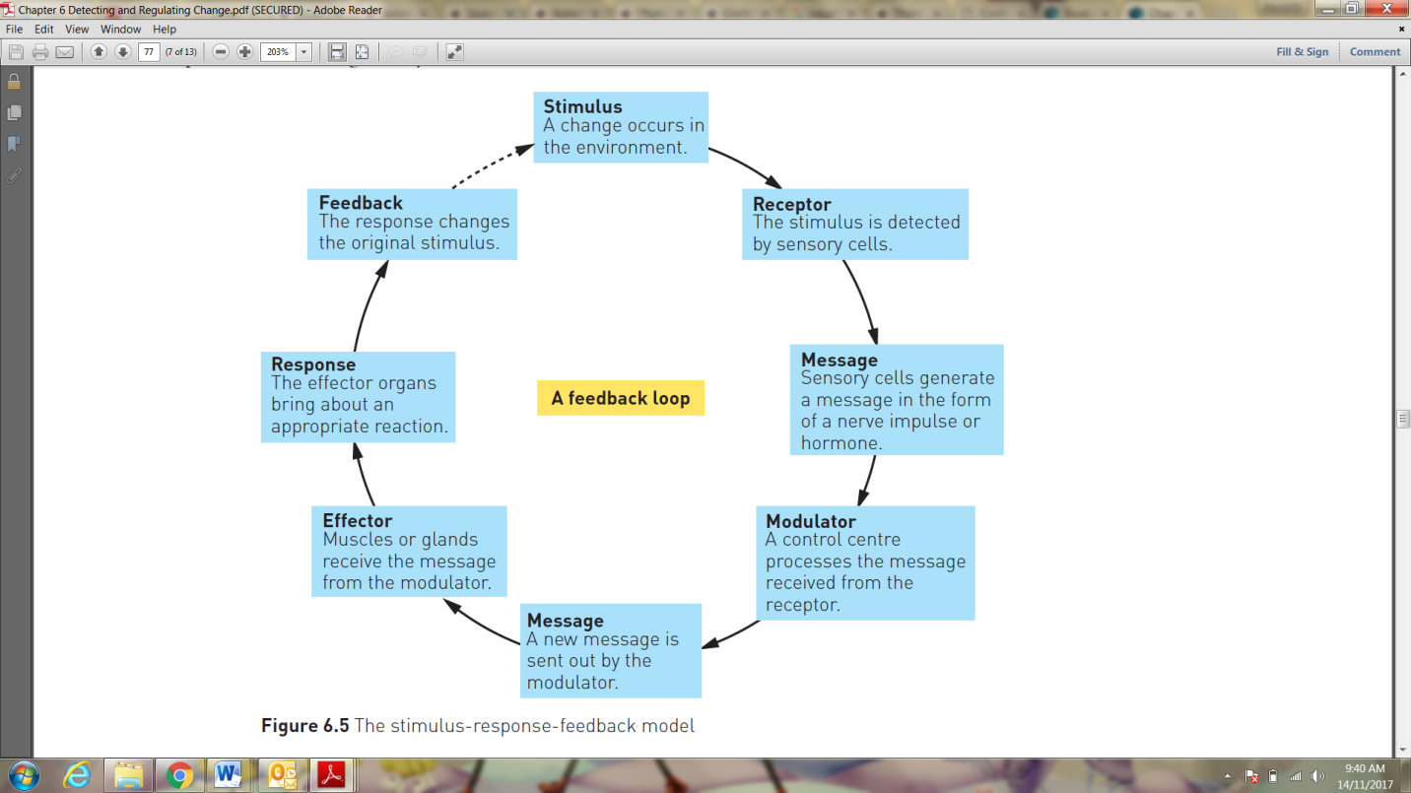

|  |  |
| --- | --- |
| Description | Mark |
| Feedback loop:  Has all the parts of a feedback loop | 3 |
| Has all parts with minor error | 1 |
| Shows that it is negative feedback – feedback is opposite of stimulus | 1 |
| Link to hormone:  Links to a hormone researched correctly | 2 |
| Links to a hormone researched, minor errors | 1 |
| TOTAL | **/6** |

1. Your Aunt Mildred has been taking medication for Hypothyroidism.
2. What hormone is not being kept in balance and name four symptoms of the condition

(3 marks)

|  |  |
| --- | --- |
| Description | Mark |
| Hormone:  Thyroxine | 1 |
| Symptoms:  All four correct  2 correct  1 correct | 2  1  0 |
| Symptoms include:  Fatigue, intolerance to cold, low heart heart rate, weigh gain, reduced appetite, poor memory, depression, stiffness of muscles, infertility. |  |
| TOTAL | **/3** |

1. Explain how the hormone is usually maintained in the body (8 marks)

|  |  |
| --- | --- |
| Description | Mark |
| When there are low levels:   * Hypothalamus secretes releasing hormone * Releasing hormone stimulates Pituitary gland * Pituitary gland secretes thyroid stimulating hormone * TSH acts on the thyroid gland to release thyroxine | 1-4 |
| When levels are high:   * Thyroxine level detected * Hypothalamus tops secreting releasing hormone * Causes pituitary to stop releasing TSH * Thyroid stops secreting thyroxine | 1-4 |
| TOTAL | **/8** |

1. Describe how hormone replacement therapy/medications can be used to treat the condition

(3 marks)

|  |  |
| --- | --- |
| Description | Mark |
| Synthetic version of hormone given (levothyroxine) | 1 |
| Gives the same effect as normal level of thyroxine in the body | 1 |
| Can also help treat other symptoms associated with hypothyroidism | 1 |
| TOTAL | **/3** |

3. Cousin Dave has not been feeling 100% of late. He stated to your dad that he has not felt as strong when he has been to the gym, his skin bruises easily, he feels like he has put weight on around his face and abdomen and has felt a bit depressed and anxious at work.

1. Name the hormone that is imbalanced causing Cousin Dave’s condition. (1 mark)

|  |  |
| --- | --- |
| Description | Mark |
| Hormone:   * Cortisol | 1 |
| TOTAL | **/1** |

1. What condition do you think Cousin Dave is suffering from? Explain why. (3 marks)

|  |  |
| --- | --- |
| Description | Mark |
| Condition:  Cushing’s Disease / Syndrome  (either is acceptable – different conditions due to too much cortisol in body) | 1 |
| Too much cortisol | 1 |
| Reasons:  Symptoms associated, are for cortisol  Gaining weight this is linked to too much cortisol | 1  1 |
| TOTAL | **/3** |

1. Explain what can be done to treat the condition you think Cousin Dave is suffering from.

(4 marks)

|  |  |
| --- | --- |
| Description | Mark |
| Student will give treatment for either the Disease or Syndrome. Any four: |  |
| * Remove pituitary tumour * Radiation therapy * Medications to block adrenal glands / decrease ACTH means decreased cortisol * Remove adrenal glands * Decreased steroid use / alternatives to steroids * Medications to decrease cortisol | 1-4 |
| TOTAL | **/4** |

4. Your Grandfather on your mum’s side was recently diagnosed with a pituitary tumour. A hormone test was performed and his cortisol level was within the normal range.

1. What hormone will likely to be affected by a pituitary tumour other than cortisol? (1 mark)

|  |  |
| --- | --- |
| Description | Mark |
| Hormone:  Growth Hormone | 1 |
| TOTAL | **/1** |

1. How would you test for the hormone level in the body? (1 mark)

|  |  |
| --- | --- |
| Description | Mark |
| Test:   * Drink a sugary drink and see if the level of GH remains high. | 1 |
| TOTAL | **/1** |

1. He has found out that he has too little of the hormone in his body:
   * 1. What are two symptoms/chronic disease that are caused by this? (2 marks)

|  |  |
| --- | --- |
| Description | Mark |
| Symptoms//Disease: *Any two:*   * Reduced sense of wellbeing * Increased fat * Increased risk of heat diease * Weak heart * Weak muscles * Weak bones | 2 |
| TOTAL | **/2** |

* + 1. Explain why receiving hormone therapy would improve your Grandfather’s quality of life.

(3 marks)

|  |  |
| --- | --- |
| Description | Mark |
| Comprehensive:*:*   * Links condition to symptoms/chronic disease and how this decreases his quality of life before intervention * Links treatment to improvement to quality of life after treatment * Uses the scientific language and links science behind hormone regulation | 3 |
| All of the above   * Some minor error * Not always scientific language | 2 |
| Basic idea   * Uses everyday terminology * Vague link to science | 1 |
| TOTAL | **/3** |